**Henderson Hummingbird Hurrah**

**August 21, 2021** 

Raffle Prizes! Tickets $5 ea. or 5 for $20

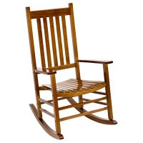**Two Wooden Porch Rockers**

your choice of brown or white

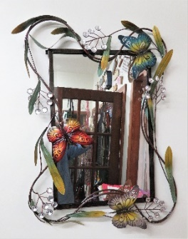 **Mirror/Metal Butterflies** 24”x32”

**3 Large Gift Baskets:** HHH 2022 Calendar, Hummingbird feeder, Ring Feeder, 8x10 framed Nature Photo, 2 Handmade Potholders, and **more**!!

**Drawing will be at 3:00 p.m. on August 21, 2021**

**2022 Calendars also For Sale!! Regular Size- $20**

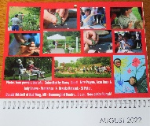 **& Desk Calendar $10 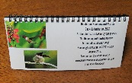 All photos on the calendars are taken in the Hummingbird Garden by our guests!!!!**